**Assignment- 3**

1. Determine the output, *X*, for a 2-input AND gate with the input waveforms shown in Figure-1.

Show the proper relationship of output to inputs with a timing diagram. Repeat for 2 input OR gate.

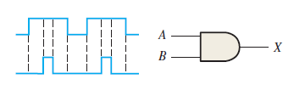Fig-1

1. The waveforms in Figure-2 are applied to points *A* and *B* of a 2-input AND gate followed by an inverter. Draw the output waveform.

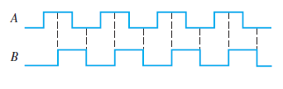Fig-2

1. Considering (Figure -2) A and B as two inputs, draw the output for 2 input OR gate, NOR gate , NAND gate, Exclusive OR , and Exclusive NOR.
2. The input waveforms applied to a 3-input AND gate are as indicated in Figure 3. Show the output waveform in proper relation to the inputs with a timing diagram. Repeat for 3 input OR gate

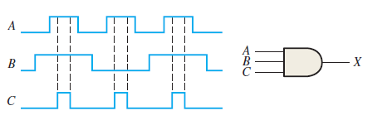Fig-3

1. The input waveforms applied to a 4-input AND gate are as indicated in Figure 4. The output of the AND gate is fed to an inverter. Draw the net output waveform of this system. Repeat for 4 input OR gate.

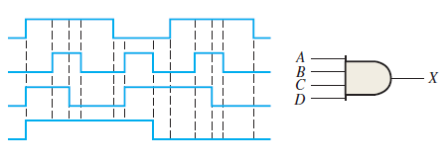Fig-4

1. For the waveforms given in Figure 5, *A* and *B* are ANDed with output *F*, *D* and *E* are ANDed with output *G*, and *C*, *F*, and *G* are ORed. Draw the net output waveform.

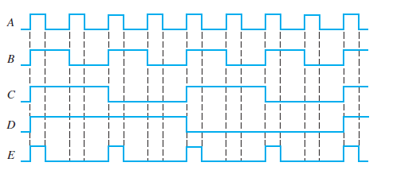Fig-5

1. Show the truth table for a system of a 3-input OR gate followed by an inverter. For the set of input waveforms in Figure 6, determine the output for the gate shown and draw the timing diagram.

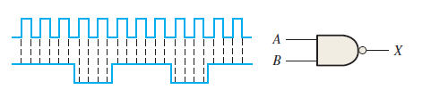Fig-6

1. Determine the gate output for the input waveforms in Figure 7 and draw the timing diagram.

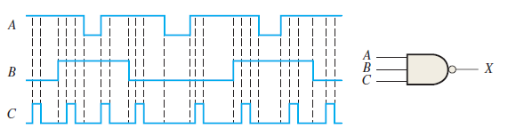Fig-7

1. As you have learned, the two logic symbols shown in Figure 8 represent equivalent operations. The difference between the two is strictly from a functional viewpoint. For the NAND symbol, look for two HIGHs on the inputs to give a LOW output. For the negative-OR, look for at least one LOW on the inputs to give a HIGH on the output. Using these two functional viewpoints, show that each gate will produce the same output for the given inputs.

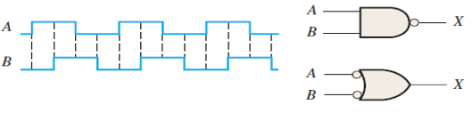Fig-8

1. Determine the output waveform in Figure 9 and draw the timing diagram.

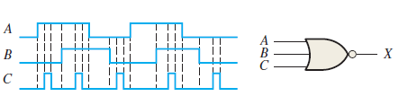Fig-9

1. The NAND and the negative-OR symbols represent equivalent operations, but they are functionally different. For the NOR symbol, look for at least one HIGH on the inputs to give a LOW on the output. For the negative-AND, look for two LOWs on the inputs to give a HIGH output. Using these two functional points of view, show that both gates in Figure 3–88 will produce the same output for the given inputs.

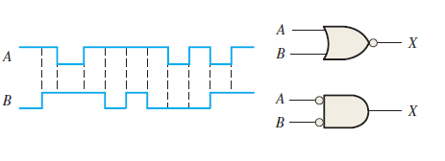Fig-10

1. How does an exclusive-OR gate differ from an OR gate in its logical operation?
2. Simplify the Boolean expressions:

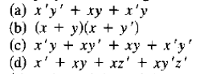

1. Simplify the Boolean expressions:

